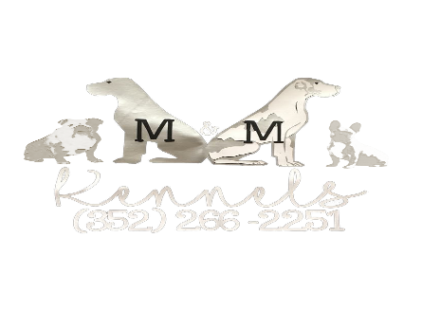
DEPOSIT/RETAINER AGREEMENT

I the Buyer, _____________________ am putting a $____ deposit/retainer towards the purchase of a ___________________Great Dane born on __________ from (Seller) Margaret Manning of M&M Kennels.

I the buyer, agree to place this deposit as a guarantee to buy the above-mentioned puppy. I understand the seller (breeder) will save above mentioned puppy for me and deny selling this puppy to other buyers who show interest.

I the buyer, agree, that my deposit/retainer will NOT be refunded at any time unless the puppy is found unfit for sale.

I further state that I am aware that there is a separate written agreement/contract that will accompany the sale of this puppy prior to my taking possession of puppy. I have reviewed it and agree to its terms prior to paying the deposit/retainer.

I understand the breeder may refund my deposit/retainer in FULL at any time of her choosing prior to me taking possession of the puppy, and refuse to sell me a puppy at
her discretion.
I agree that I will pay 50% of the remaining balance due at 6 weeks of age. I understand as the buyer that my balance must be paid cash at pick up, if not paying in cash the balance must be paid in full 72 hours prior to transport or pick up. By signing this contract, I am also in agreeance that I will pick up or have transport arranged for my puppy by the Sunday after the puppy is 8 weeks of age. If the breeder needs to hold the puppy beyond that time, I agree to pay $10 per day boarding and this must be arranged prior to pick up. I also agree that if I am having to make this arrangement for the breeder to hold the puppy the balance will be paid in full at time of arrangement.
Buyer (print) _______________________________________
Phone _________________________ Date:___________
Buyer signature_______________________________________

